**Structure Of Compiler**

The compilation process contains the sequence of various phases. Each phase takes source program in one representation and produces output in another representation. Each phase takes input from its previous stage.

There are the various phases of compiler:

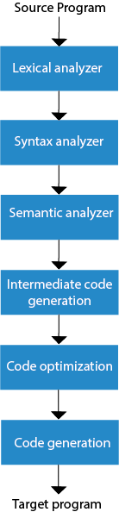

Lexical Analysis:

Lexical analyzer phase is the first phase of compilation process. It takes source code as input. It reads the source program one character at a time and converts it into meaningful lexemes or token. Lexical analyzer represents these lexemes in the form of tokens.lexical analysis conver source code into tokens. In lexical we use finite automata(DFA ,BFA)

Syntax Analysis

Syntax analysis is the second phase of compilation process. It takes tokens as input and generates a parse tree as output. In syntax analysis phase, the parser checks that the expression made by the tokens is syntactically correct or not.

Semantic Analysis

Semantic analysis is the third phase of compilation process. It checks logical error like variable is declear or not and and parenthicis is declear or not etc. Here we use SDT(syntax Directaly translater) to check error. Semantic analyzer keeps track of identifiers, their types and expressions. The output of semantic analysis phase is the annotated tree syntax.

Intermediate Code Generation

intermediate code generation is the forth stage of compiler. It is convert the code into three address code. Suppose we generate code on window but we can also on unix,mac,linix etc. it is the main phase of compiler . it is help to convert the code into height level language to machine language.

Code Optimization

Code optimization is an optional phase. It is used to improve the intermediate code. Like :- It`s help to decrease the line of code , it`s help to remove the double comma from code. so that the output of the program could run faster and take less space. It removes the unnecessary lines of the code and arranges the sequence of statements in order to speed up the program execution.

Code Generation

Code generation is the final stage of the compilation process. It takes the optimized intermediate code as input and convert to the target machine language. Code generator translates the intermediate code into the machine code of the specified computer.

**Example:**

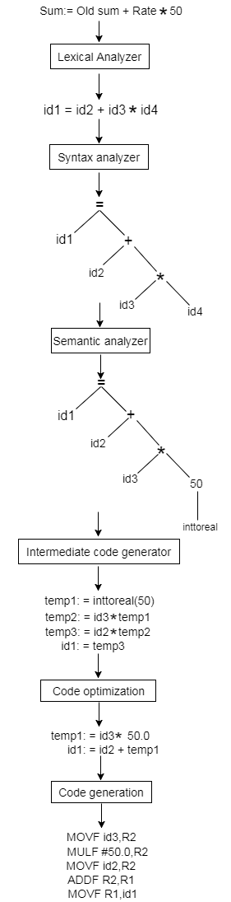

**Lexical analysis**

Lexical analysis is the first phase of the Compiler It helps to convert the code into tokens like:- int,+,=,{,},(,),%,$ etc. it caintane the tokens like:- int (keyword), value (identifier), = (operator), 100 (constant) and ; (symbol).

lexical analysis proved the error when we write unuse syntax in code like:-#,@ etc.

If the lexical analyzer finds a token invalid, it generates an error. The lexical analyzer works closely with the syntax analyzer. It reads character streams from the source code, checks for legal tokens, and passes the data to the syntax analyzer when it demands.

And also ignore the comments. 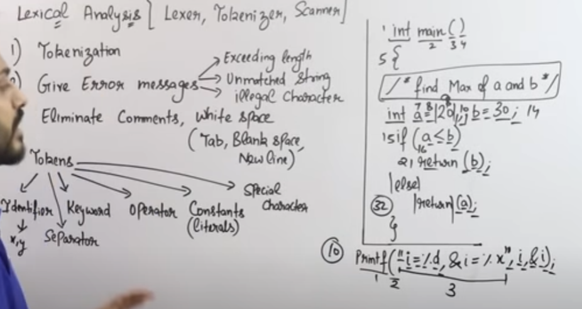

**Role of lexical analysis**

The lexical analysis is the first phase of the compiler where a lexical analyser operate as an interface between the source code and the rest of the phases of a compiler. It reads the input characters of the source program, groups them into lexemes, and produces a sequence of tokens for each lexeme. The tokens are sent to the parser for syntax analysis.

If the lexical analyzer is located as a separate pass in the compiler it can need an intermediate file to locate its output, from which the parser would then takes its input. It can eliminate the need for the intermediate file, the lexical analyzer and the syntactic analyser (parser) are often grouped into the same pass where the lexical analyser operates either under the control of the parser or as a subroutine with the parser.

The lexical analyzer also interacts with the symbol table while passing tokens to the parser. Whenever a token is discovered, the lexical analyzer returns a representation for that token to the parser. If the token is a simple construct including parenthesis, comma, or a colon, then it returns an integer program. If the token is a more complex items including an identifier or another token with a value, the value is also passed to the parser.

Lexical analyzer separates the characters of the source language into groups that logically belong together, called tokens. It includes the token name which is an abstract symbol that define a type of lexical unit and an optional attribute value called token values. Tokens can be identifiers, keywords, constants, operators, and punctuation symbols including commas and parenthesis. A rule that represent a group of input strings for which the equal token is make as output is called the pattern.

Regular expression plays an essential role in specifying patterns. If a keyword is treated as a token, the pattern is only a sequence of characters. For identifiers and various tokens, patterns form a difficult structure.

The lexical analyzer also handles issues including stripping out the comments and whitespace (tab, newline, blank, and other characters that are used to separate tokens in the input). The correlating error messages that are generated by the compiler during lexical analyzer with the source program.

For example, it can maintain track of all newline characters so that it can relate an ambiguous statement line number with each error message. It can be implementing the expansion of macros, in the case of macro, pre-processors are used in the source program.

# Input Buffering

Lexical Analysis has to access secondary memory each time to identify tokens. It is time-consuming and costly. So, the input strings are stored into a buffer and then scanned by Lexical Analysis.

Lexical Analysis scans input string from left to right one character at a time to identify tokens. It uses two pointers to scan tokens −

* **Begin Pointer (bptr)** − It points to the beginning of the string to be read.
* **Look Ahead Pointer (lptr)** − It moves ahead to search for the end of the token.

**Buffer is store the value of lexical one by one.**

**Example** − For statement int a, b;

* Both pointers start at the beginning of the string, which is stored in the buffer.

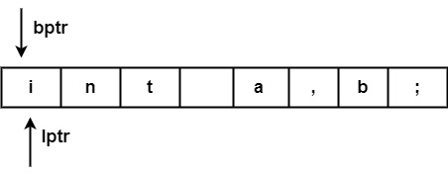

* Look Ahead Pointer scans buffer until the token is found.

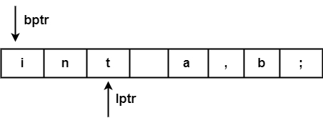

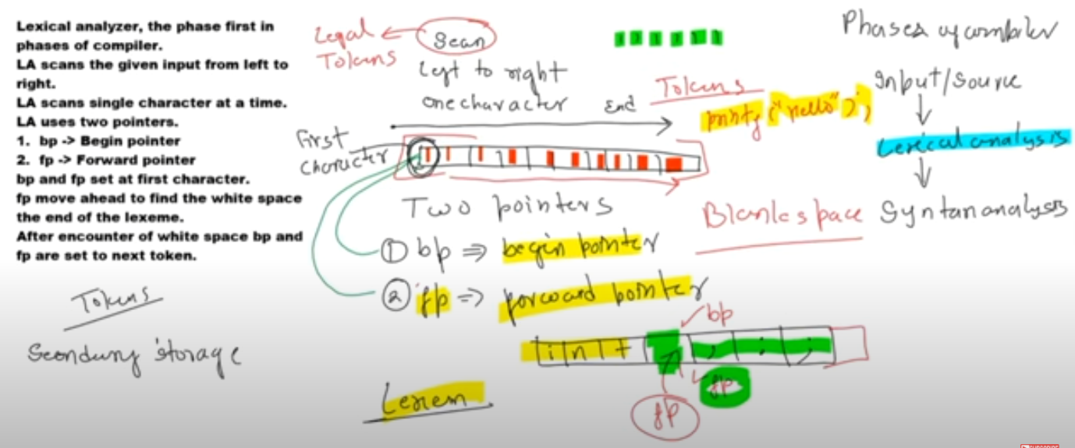

**Specification of Tokens**

**Recognization of token**

**Lex**

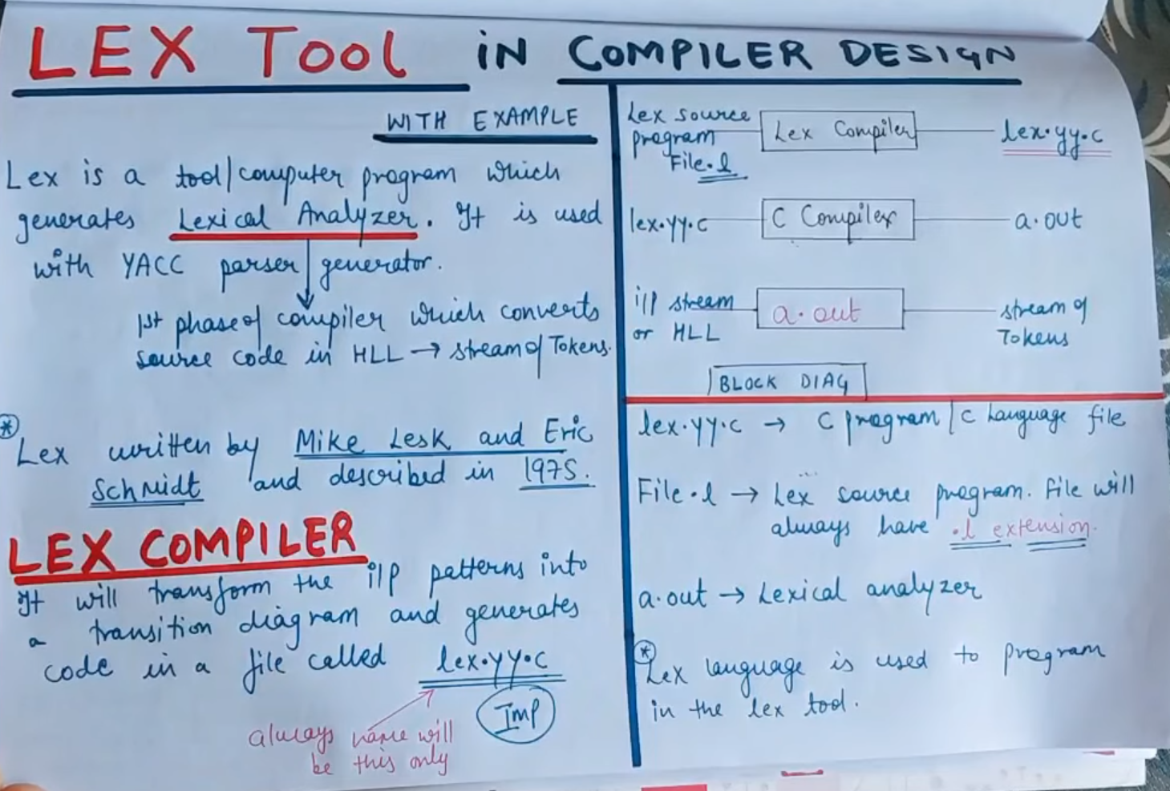

It`s use to convert the code like this:-

First Ganerate file.l

After that convert in c anguage lex.yy.c

After that convert HLL(Height Level Language to low Level language.

There are three steps:-

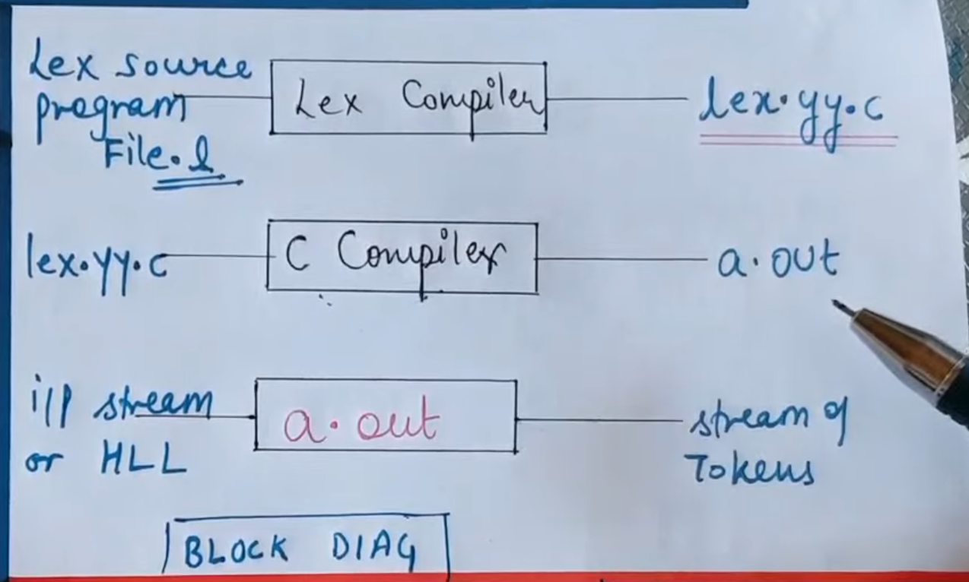

Definition of steps:-

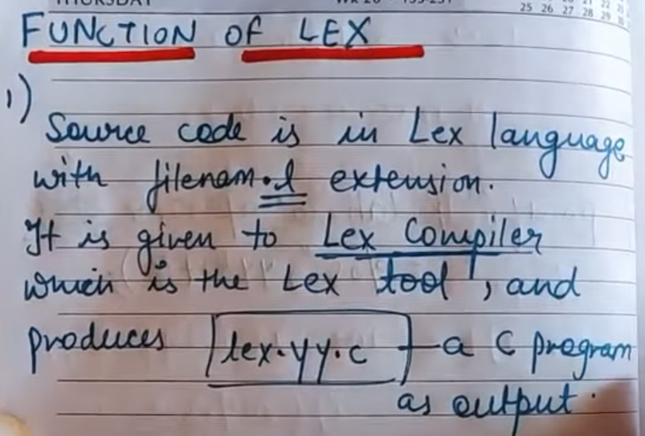

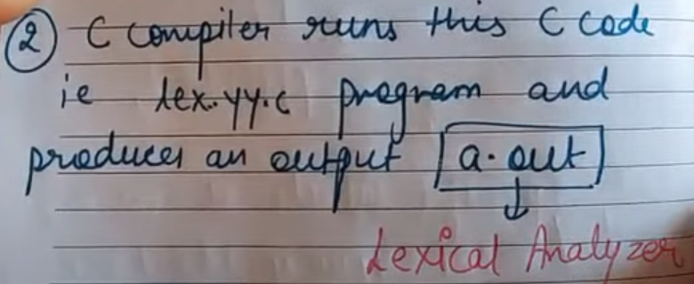

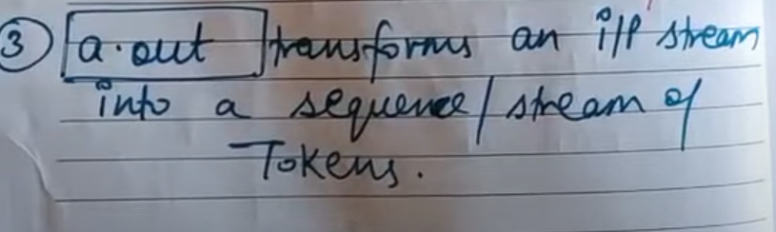

**Syntax of lex:-**

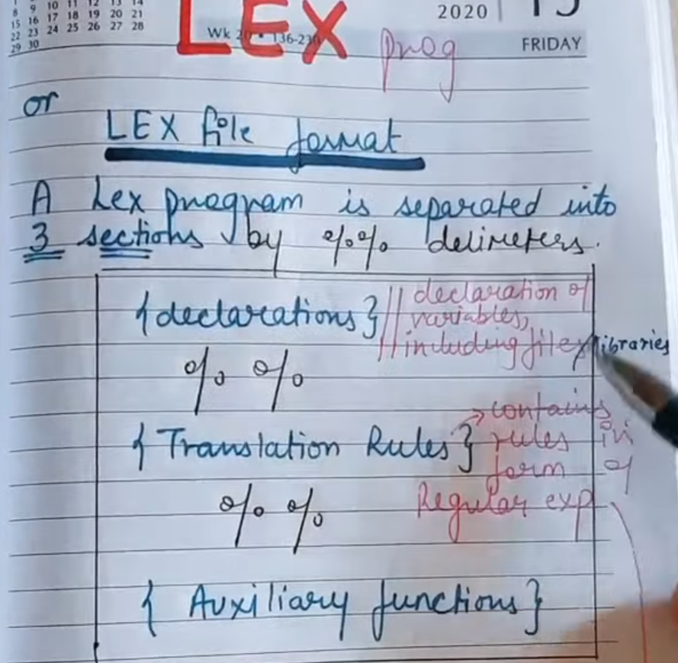

**Ex:-**

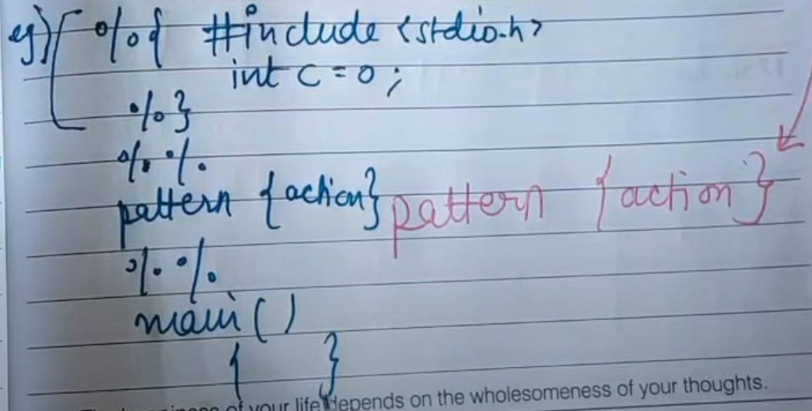

**Finite autometa**

Finite automata is a state machine that collect a string of symbols as input and changes its state accordingly. Finite automata is a recognizer for regular expressions. Finite autometa have five tupals. it changes state when input symbol is 1. The mathematical model of finite automata consists of:

* Finite set of states (Q)
* Finite set of input symbols (Σ)
* One Start state (q0)
* Set of final states (qf)
* Transition function (δ)

The transition function (δ) maps the finite set of state (Q) to a finite set of input symbols (Σ), Q × Σ ➔ Q

Finite Automata Construction

Let L(r) be a regular language recognized by some finite automata (FA).

* **States** : States of FA are represented by circles. State names are written inside circles.
* **Start state** : The state from where the automata starts, is known as the start state. Start state has an arrow pointed towards it.
* **Intermediate states** : All intermediate states have at least two arrows; one pointing to and another pointing out from them.
* **Final state** : If the input string is successfully parsed, the automata is expected to be in this state. Final state is represented by double circles. It may have any odd number of arrows pointing to it and even number of arrows pointing out from it. The number of odd arrows are one greater than even, i.e. **odd = even+1**.
* **Transition** : The transition from one state to another state happens when a desired symbol in the input is found. Upon transition, automata can either move to the next state or stay in the same state. Movement from one state to another is shown as a directed arrow, where the arrows points to the destination state. If automata stays on the same state, an arrow pointing from a state to itself is drawn.

**Example** : We assume FA accepts any three digit binary value ending in digit 1. FA = {Q(q0, qf), Σ(0,1), q0, qf, δ}

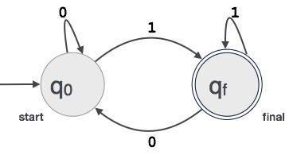

# Regular Expression:-

* Regular expression is use to describe the language . Regular expression is describe that language who is accepted by Finite automata.
* The languages accepted by some regular expression are referred to as Regular languages.

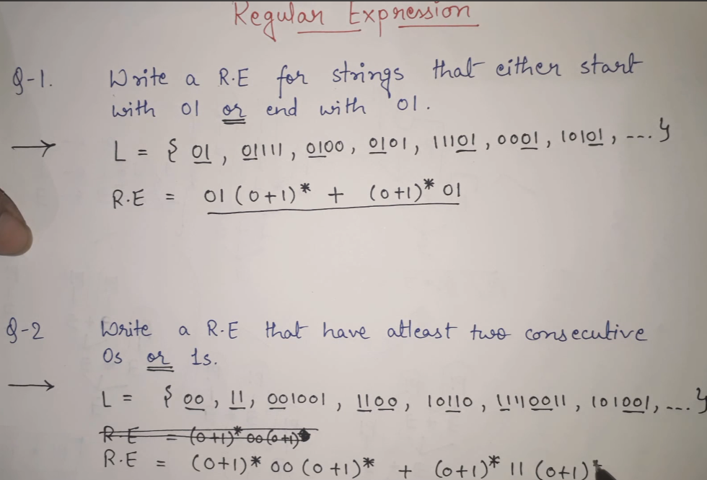

### Example 1:

Write the regular expression for the language accepting all combinations of a's, over the set ∑ = {a}

**Solution:**

All combinations of a's means a may be zero, single, double and so on. If a is appearing zero times, that means a null string. That is we expect the set of {ε, a, aa, aaa, ....}. So we give a regular expression for this as:

1. R = a*

That is Kleen closure of a.

### Example 2:

Write the regular expression for the language accepting all combinations of a's except the null string, over the set ∑ = {a}

**Solution:**

The regular expression has to be built for the language

1. L = {a, aa, aaa, ....}

This set indicates that there is no null string. So we can denote regular expression as:

R = a+

### Example 3:

Write the regular expression for the language accepting all the string containing any number of a's and b's.

**Solution:**

The regular expression will be:

1. r.e. = (a + b)*

This will give the set as L = {ε, a, aa, b, bb, ab, ba, aba, bab, .....}, any combination of a and b.

The (a + b)* shows any combination with a and b even a null string.

# Conversion Regular Expression to Finite Automata:-

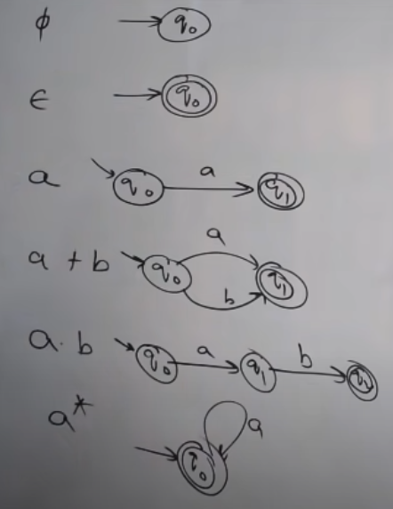

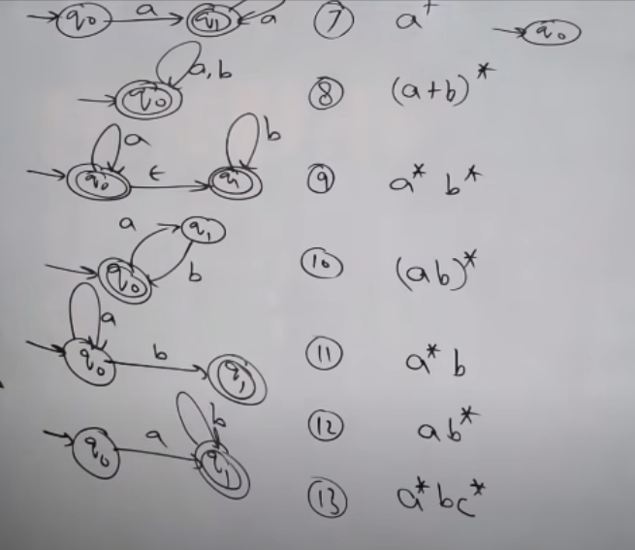

# DFA(Deterministic Finite Automata)

* DFA refers to deterministic finite automata. Deterministic refers to the uniqueness of the computation. The finite automata are called deterministic finite automata if the machine is read an input string one symbol at a time.
* In DFA, there is only one path for input to move from the current state to the next state.
* DFA does not accept the null move, i.e., the DFA cannot change state without any input character.
* DFA can contain multiple final states. It is used in Lexical Analysis in Compiler.

**🡪** A DFA is a collection of 5-tuples same as we described in the definition of FA.

1. Q: finite set of states
2. ∑: finite set of the input symbol
3. q0: initial state
4. F: **final** state
5. δ: Transition function

Ex. Of DFA:-

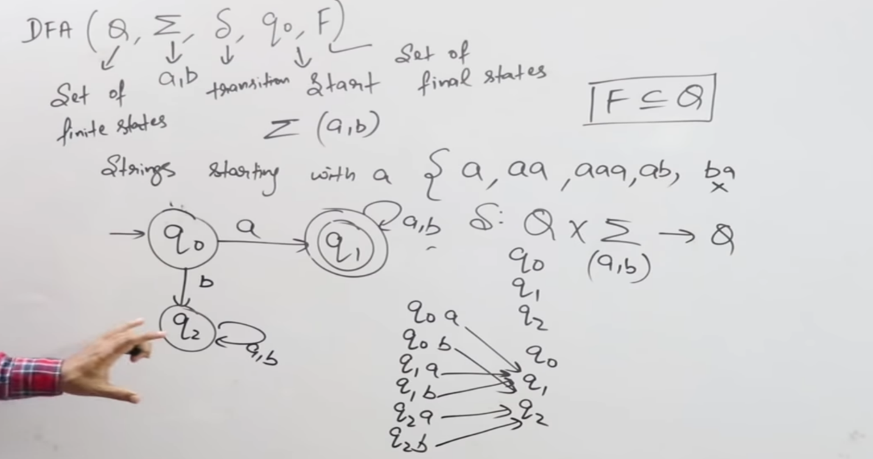

:- For containing ‘a’.

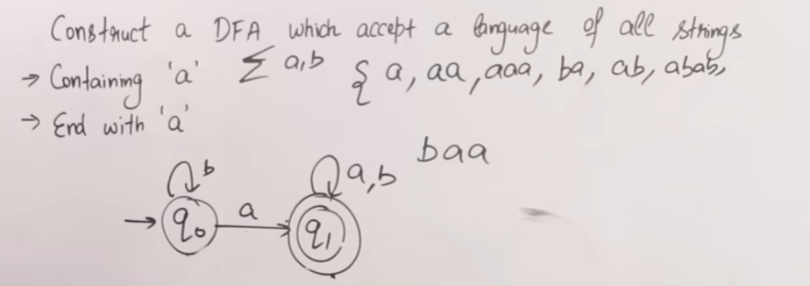

:- For ending with ‘a’.

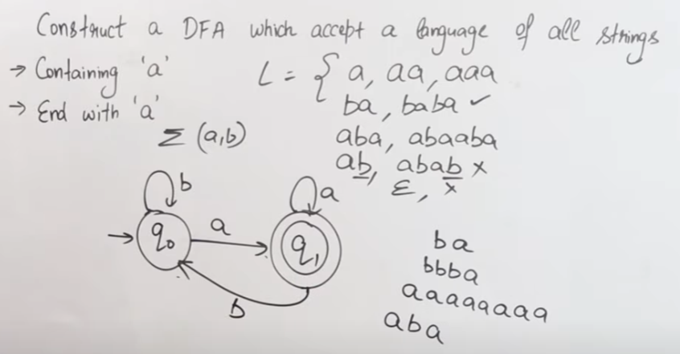

# Non-Deterministic Finite Automata:-

NFA stands for non-deterministic finite automata. It is easy to construct an NFA when compared to DFA for a given regular language.

The finite automata are called NFA when there exist many paths for specific input from the current state to the next state.

Each NFA can be translated into DFA but every NFA is Not DFA.

NFA is defined in the same way as DFA but with the following two exceptions, which are as follows –

* It contains multiple next states.
* It contains ε transitions.

Non-deterministic finite automata is defined as a 5 tuple,

M=(Q, Σ, δ,q0,F)

Where,

* Q: Finite set of states
* Σ: Finite set of the input symbol
* q0: Initial state
* F: Final state
* δ: Transition function: Q X Σ -> 2Q
* 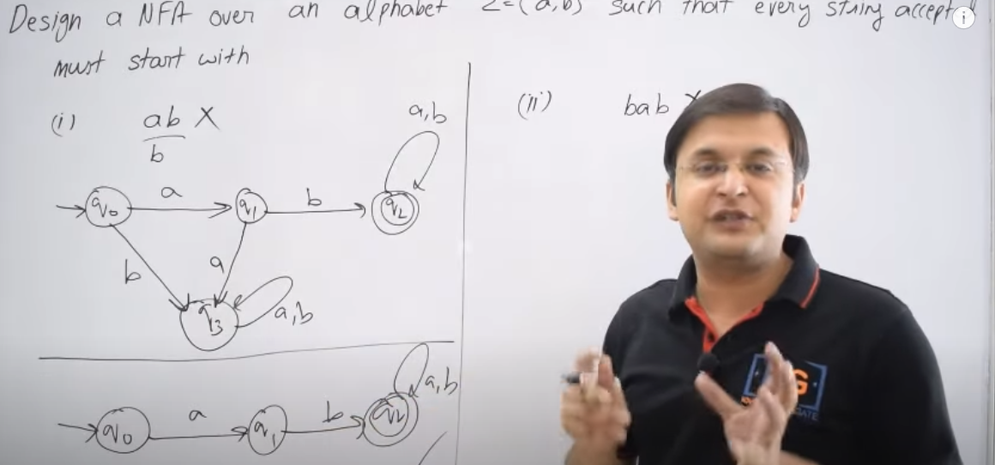



* 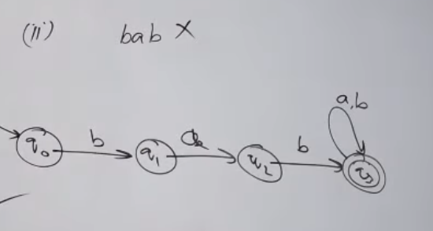

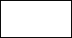

* **DIFFERENT BETWEEN DFA & NFA:-**

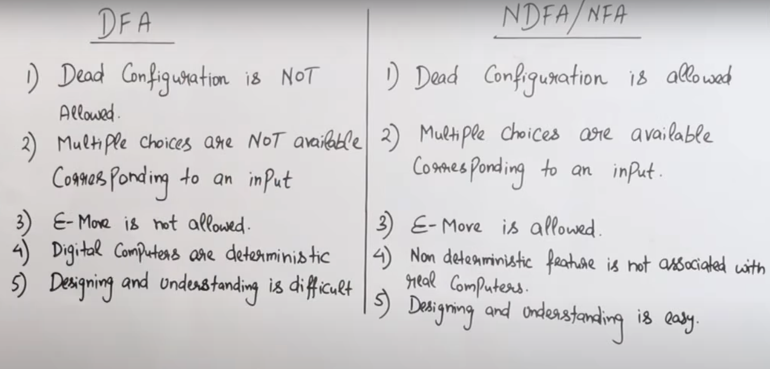

* **CONVERT NFA TO DFA:-**

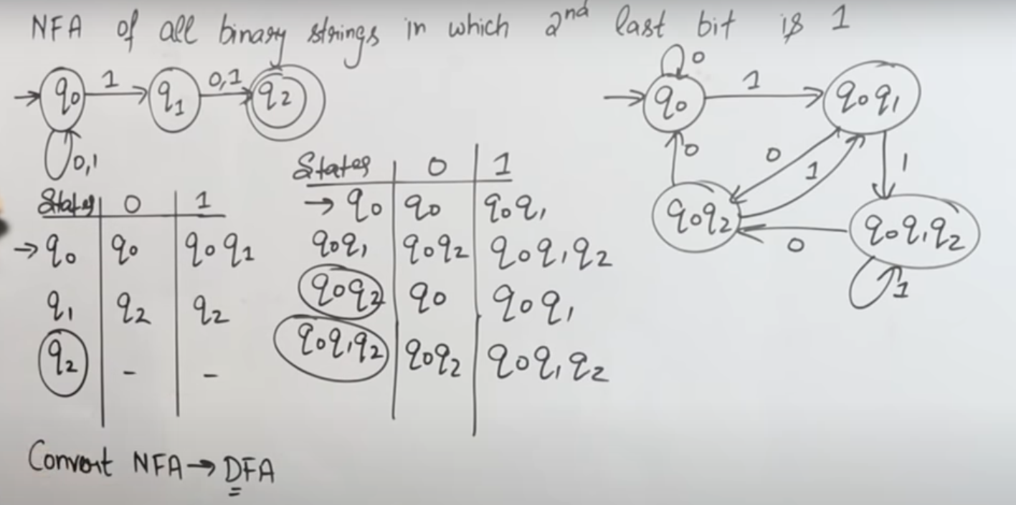

MINIMIZATION OF FINITE AUTOMATA:-

Minimization is use to minimize the states from automata(DFA , NFA).

It is minimize the state between initial state to finalization state.

In other word , Minimization of DFA means reducing the number of states from given FA(finite automata).

**There is some terms to minimize of DFA.**

**We have to follow the various steps to minimize the DFA. These are as follows:-**

**Step 1:** Remove all the states that are unreachable from the initial state via any set of the transition of DFA.

**Step 2:** Draw the transition table for all pair of states.

**Step 3:** Now split the transition table into two tables T1 and T2. T1 contains all final states, and T2 contains non-final states.

**Step 4:** Find similar rows from T1 such that:

1. 1. δ (q, a) = p
2. 2. δ (r, a) = p

That means, find the two states which have the same value of a and b and remove one of them.

**Step 5:** Repeat step 3 until we find no similar rows available in the transition table T1.

**Step 6:** Repeat step 3 and step 4 for table T2 also.

**Step 7:** Now combine the reduced T1 and T2 tables. The combined transition table is the transition table of minimized DFA.

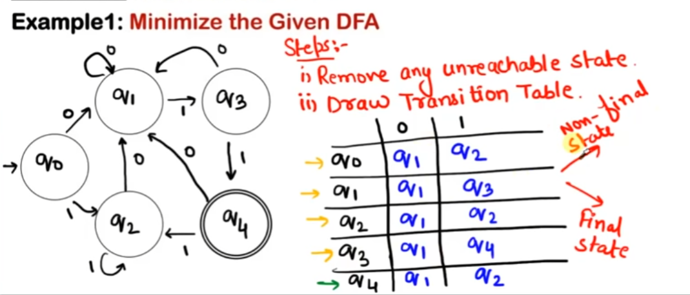

**Divide the table in two part non-final state and final state:-**

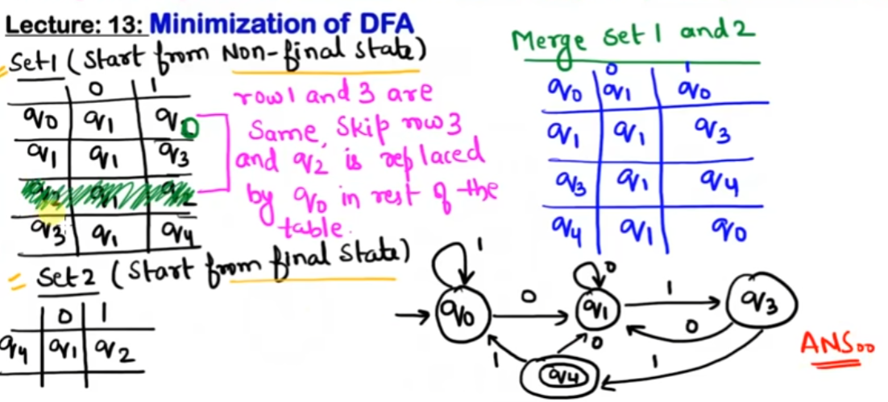

**Unit - II**

**ROLE OF PARSER**

The parser or syntactic analyzer obtains a string of tokens from the lexical analyzer and verifies that the string can be generated by the grammar for the source language. It reports any syntax errors in the program. It also recovers from commonly occurring errors so that it can continue processing its input.

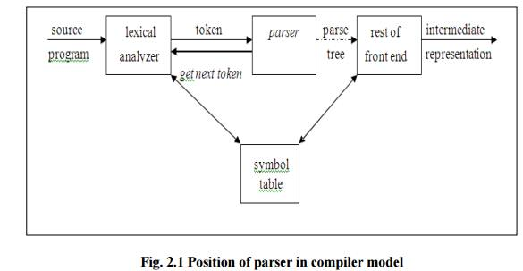

## **Context-Free Grammar**

In this section, we will first see the definition of context-free grammar and introduce terminologies used in parsing technology.

A context-free grammar has four components:

* A set of **non-terminals** (V). Non-terminals are syntactic variables that denote sets of strings. The non-terminals define sets of strings that help define the language generated by the grammar.
* A set of tokens, known as **terminal symbols** (Σ). Terminals are the basic symbols from which strings are formed.
* A set of **productions** (P). The productions of a grammar specify the manner in which the terminals and non-terminals can be combined to form strings. Each production consists of a **non-terminal** called the left side of the production, an arrow, and a sequence of tokens and/or **on- terminals**, called the right side of the production.
* One of the non-terminals is designated as the start symbol (S); from where the production begins.

The strings are derived from the start symbol by repeatedly replacing a non-terminal (initially the start symbol) by the right side of a production, for that non-terminal.

### Example

We take the problem of palindrome language, which cannot be described by means of Regular Expression. That is, L = { w | w = wR } is not a regular language. But it can be described by means of CFG, as illustrated below:

G = ( V, Σ, P, S )

**Error handling**

The tasks of the **Error Handling** process are to detect each error, report it to the user, and then make some recovery strategy and implement them to handle the error. During this whole process processing time of the program should not be slow.

Functions of Error Handler:

* Error Detection
* Error Report
* Error Recovery

Error handler=Error Detection+Error Report+Error Recovery.

 An **Error** is the blank entries in the symbol table.

Errors in the program should be detected and reported by the parser.  Whenever an error occurs, the parser can handle it and continue to parse the rest of the input. Although the parser is mostly responsible for checking for errors, errors may occur at various stages of the compilation process.  
So, there are many types of errors and some of these are:  
**Types**or**Sources of Error –** There are three types of error: logic, run-time and compile-time error: 

1. **Logic errors** occur when programs operate incorrectly but do not terminate abnormally (or crash). Unexpected or undesired outputs or other behaviour may result from a logic error, even if it is not immediately recognized as such.
2. A **run-time error** is an error that takes place during the execution of a program and usually happens because of adverse system parameters or invalid input data. The lack of sufficient memory to run an application or a memory conflict with another program and logical error is an example of this. Logic errors occur when executed code does not produce the expected result. Logic errors are best handled by meticulous program debugging.
3. **Compile-time errors** rise at compile-time, before the execution of the program. Syntax error or missing file reference that prevents the program from successfully compiling is an example of this.

**Parsing Tree**

# 

**Top Down Parser**

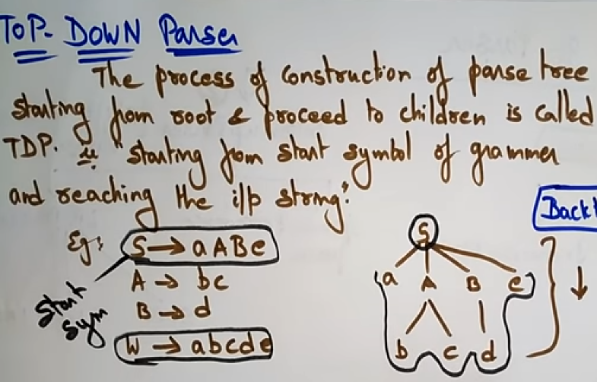

We have learnt in the last chapter that the top-down parsing technique parses the input, and starts constructing a parse tree from the root node gradually moving down to the leaf nodes. The types of top-down parsing are depicted below:

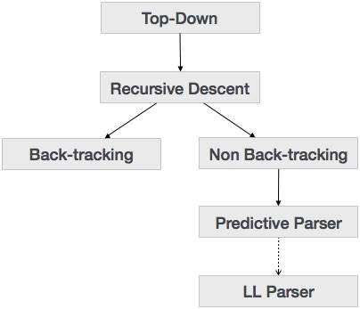

Top Down Parser is a left most derivation . It`s trevers from left side.

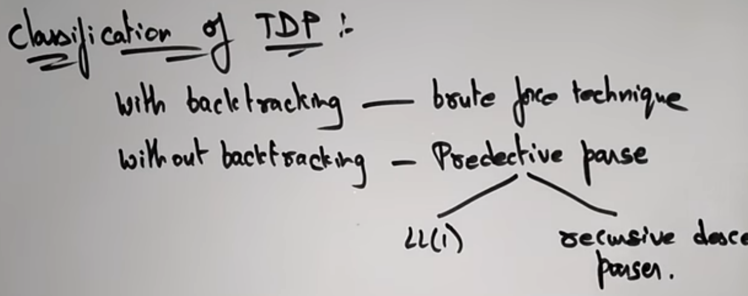

### Recursive Descent Parsing

Recursive descent is a top-down parsing technique that constructs the parse tree from the top to buttom and the input is read from left to right. It uses procedures for every terminal and non-terminal entity.

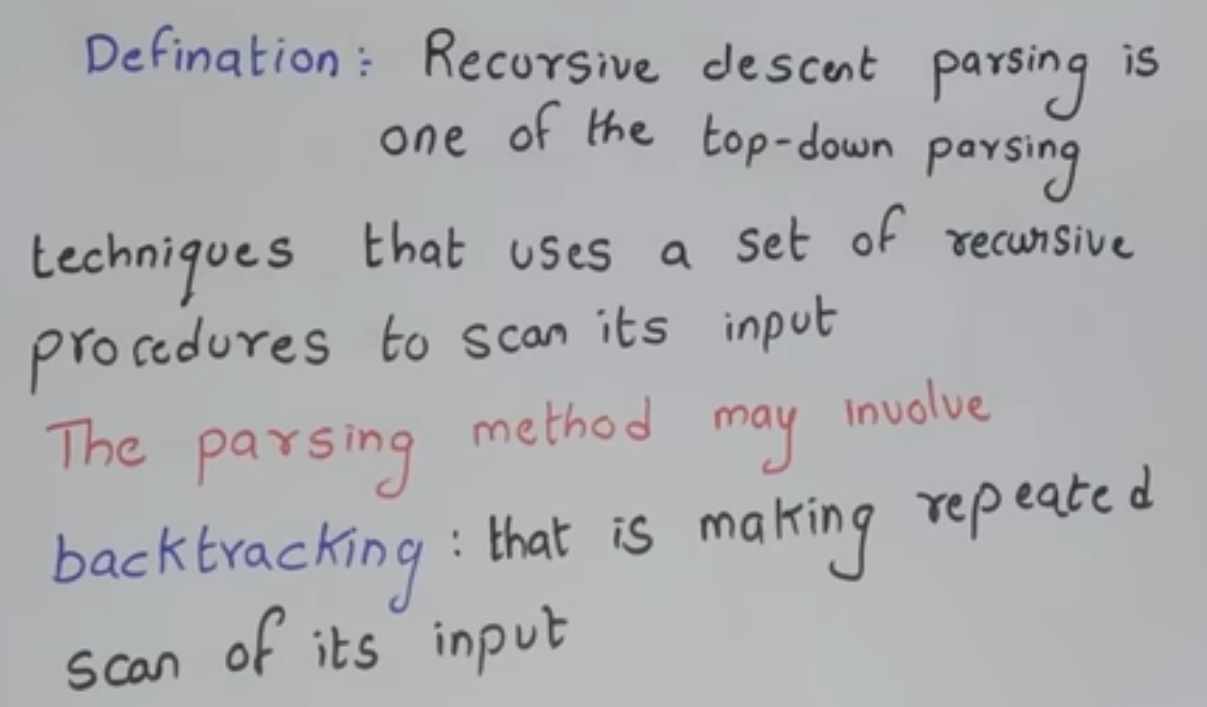

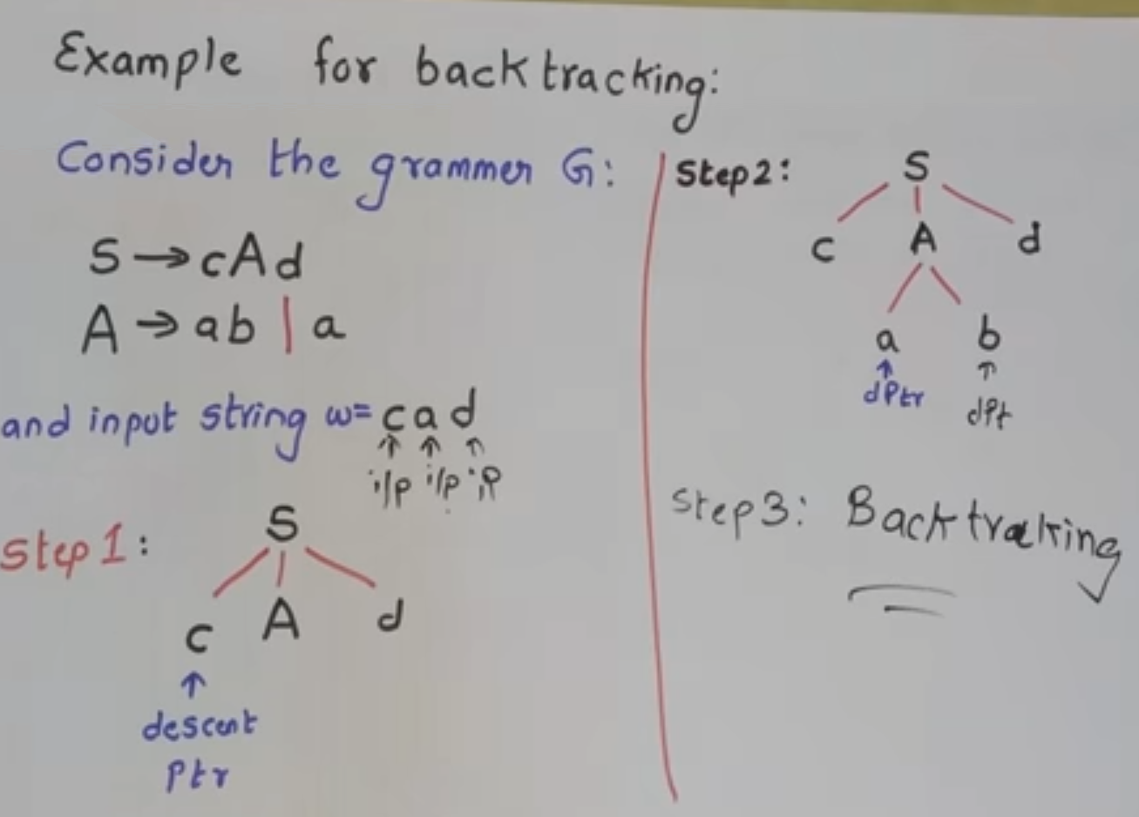

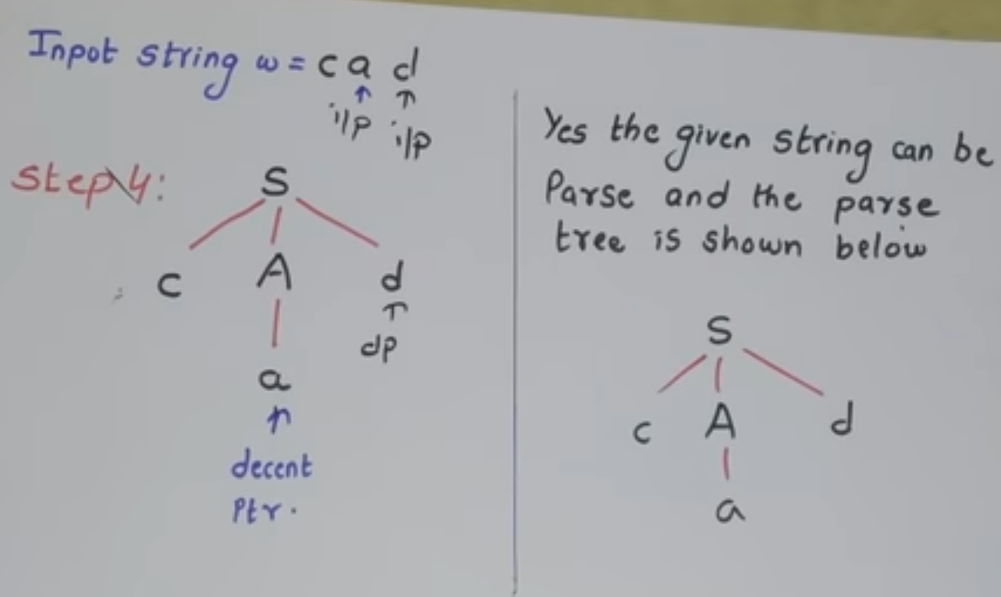

**Find First**

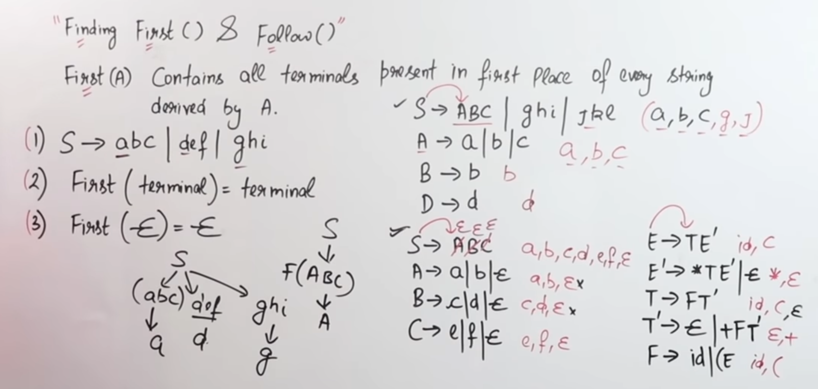

**Find Follow**

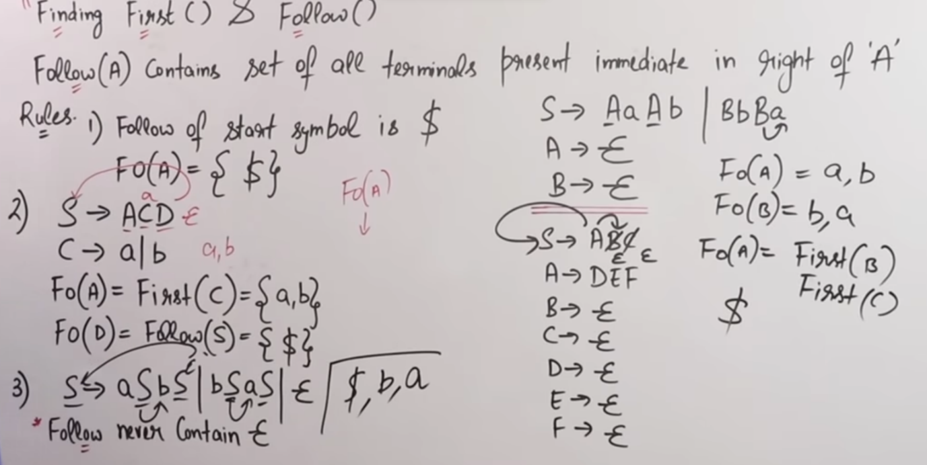

**LL(1) Table**

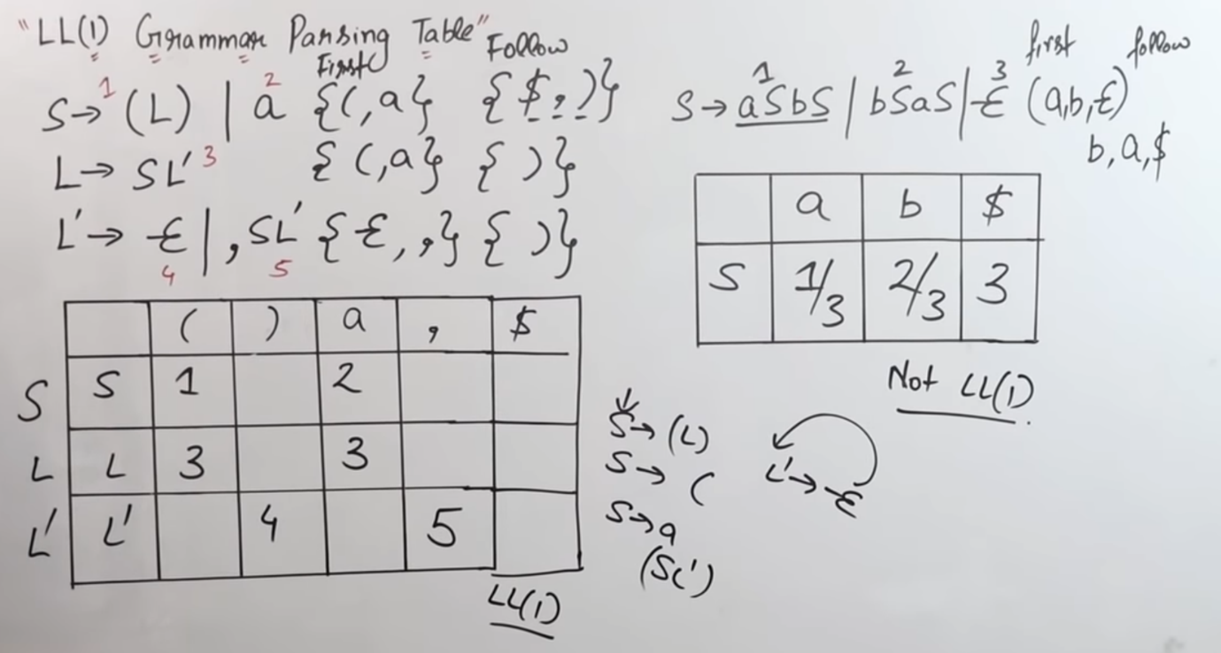

**Predictive Parser**

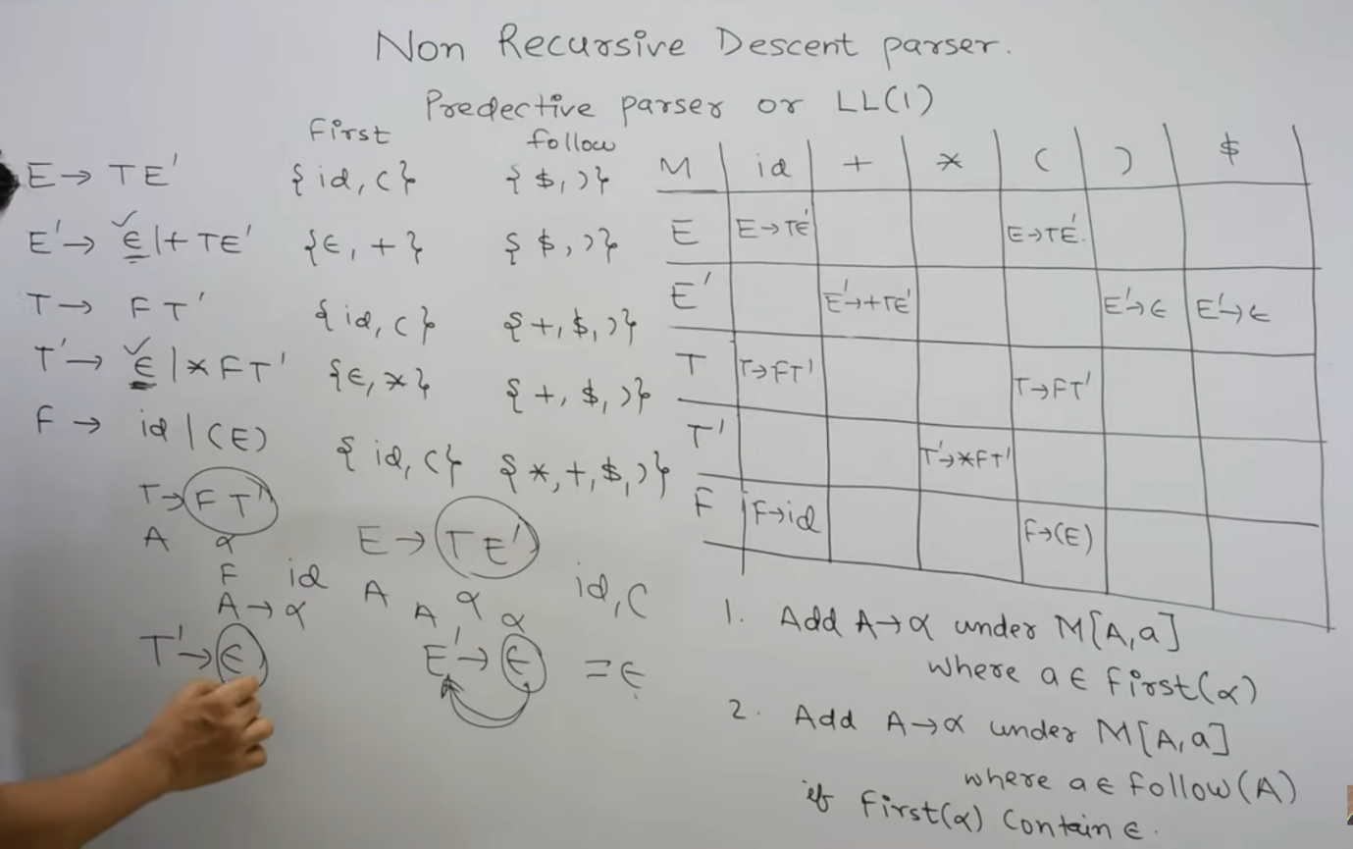

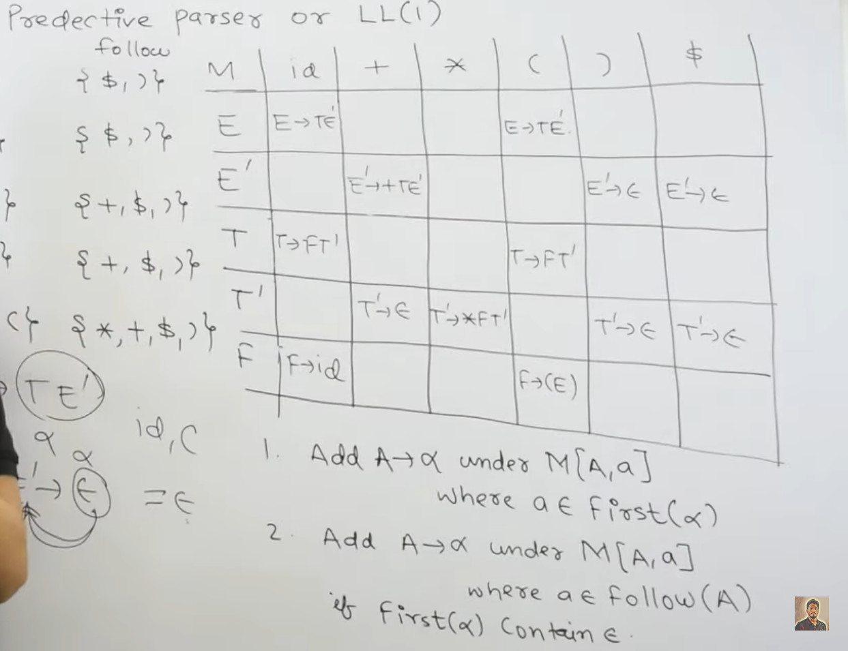

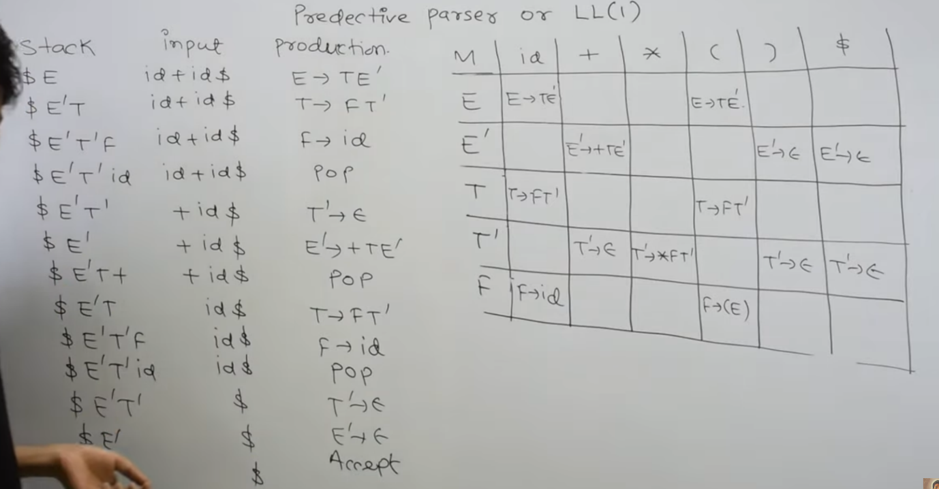

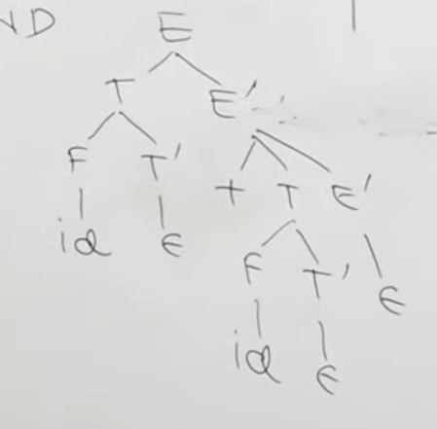

**UNIT – III**

**Syntax Directed Definitions**

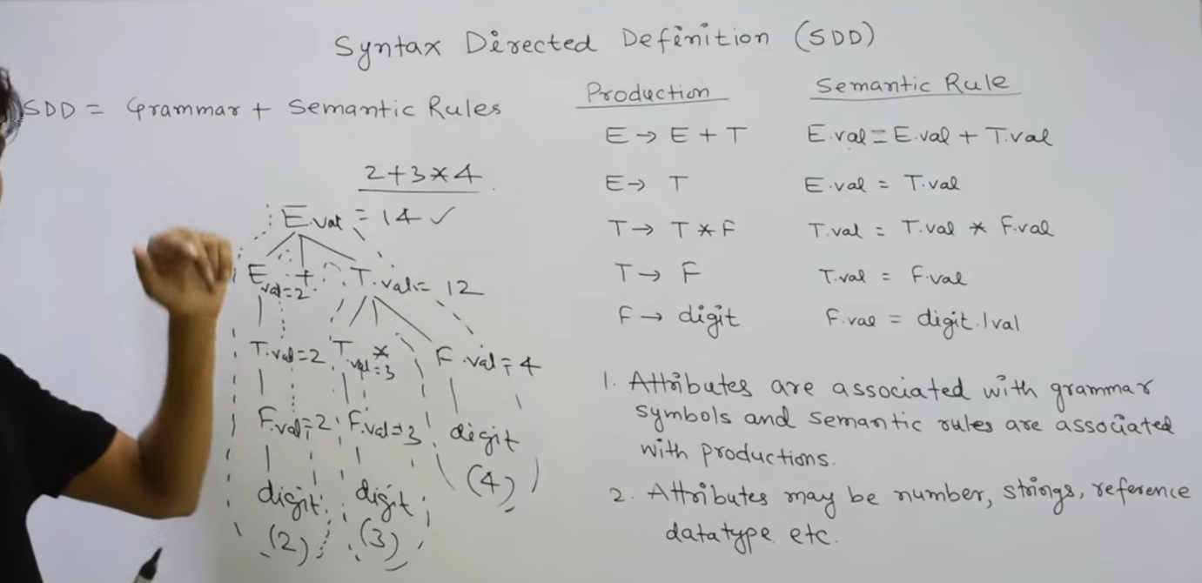

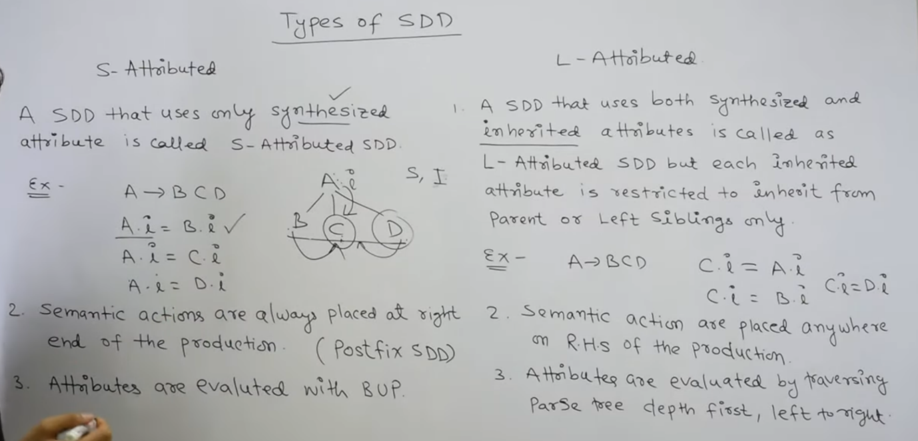

**Syntax Directed Definition (SDD):-** is a type of abstract specification. It is generalization of context free grammar in which each grammar production **X –> a**is associated with it a set of production rules of the form s = f(b1, b2, ……bk) where s is the attribute obtained from function f. The attribute can be a string, number, type or a memory location. Semantic rules are fragments of code which are embedded usually at the end of production and enclosed in curly braces ({ }).

**Example:**

E --> E1 + E --> E1



**Annotated Parse Tree: –** The parse tree containing the values of attributes at each node for given input string is called annotated or decorated parse tree.

**Features –**

* High level specification
* Hides implementation details
* Explicit order of evaluation is not specified

**There are two types of attributes**

**1. Synthesized Attributes –** These are those attributes which derive their values from their children nodes i.e. value of synthesized attribute at node is computed from the values of attributes at children nodes in parse tree.

**Example:**

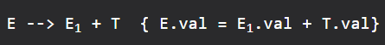

**Computation of Synthesized Attributes –**

* Write the SDD using appropriate semantic rules for each production in given grammar.
* The annotated parse tree is generated and attribute values are computed in bottom up manner.
* The value obtained at root node is the final output.

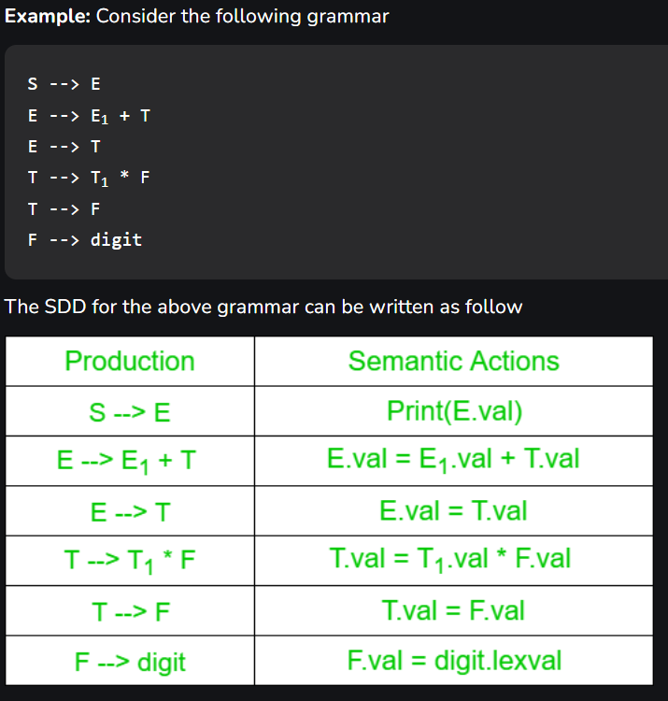

1. **Inherited Attributes –** These are the attributes which derive their values from their parent or sibling nodes i.e. value of inherited attributes are computed by value of parent or sibling nodes. It can derive the value only from left to right.   
   **Example:**

} 

**Computation of Inherited Attributes –**

* Construct the SDD using semantic actions.
* The annotated parse tree is generated and attribute values are computed in top down manner.

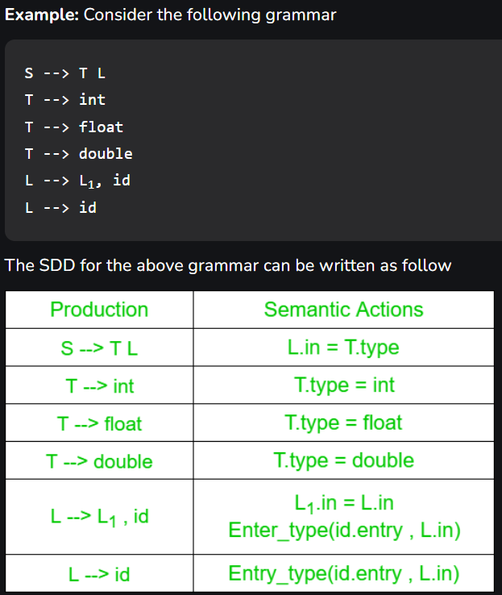

evaluation orders for syntax directed definitions

**Evaluation Orders For Syntax Directed Definitions**

**It is not Done**

**Intermediate Language**

In the context of Compiler Design, an Intermediate Language (IL) is a low-level, platform-independent programming language that serves as an intermediate step between the source code and the target code generated by a compiler.

An Intermediate Language is designed to be easy to analyze, optimize and transform by the compiler. It is typically represented as a tree or graph structure that represents the semantic meaning of the source code in a structured and machine-readable format.

The use of an Intermediate Language allows the compiler to perform a range of optimizations on the code, such as dead code elimination, constant folding, loop unrolling, and register allocation, among others. This can result in more efficient code generation and better performance of the final program.

Some examples of Intermediate Languages used in compilers are LLVM IR (Intermediate Representation), Java bytecode, and Microsoft Intermediate Language (MSIL).

**Parse tree and Syntax tree**

When you create a parse tree then it contains more details than actually needed. So, it is very difficult to compiler to parse the parse tree. Take the following parse tree as an example:

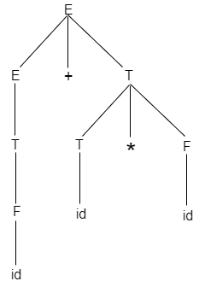

* In the parse tree, most of the leaf nodes are single child to their parent nodes.
* In the syntax tree, we can eliminate this extra information.
* Syntax tree is a variant of parse tree. In the syntax tree, interior nodes are operators and leaves are operands.
* Syntax tree is usually used when represent a program in a tree structure.

A sentence **id + id * id** would have the following syntax tree:

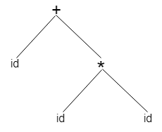

Abstract syntax tree can be represented as:

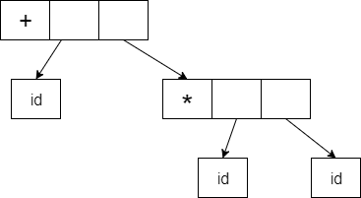

Abstract syntax trees are important data structures in a compiler. It contains the least unnecessary information.

Abstract syntax trees are more compact than a parse tree and can be easily used by a compiler.

**Three address code**

* Three-address code is an intermediate code. It is used by the optimizing compilers.
* In three-address code, the given expression is broken down into several separate instructions. These instructions can easily translate into assembly language.
* Each Three address code instruction has at most three operands. It is a combination of assignment and a binary operator.

Example

GivenExpression:

1. a := (-c * b) + (-c * d)

Three-address code is as follows:

t1 := -c

t2 := b*t1

t3 := -c

t4 := d * t3

t5 := t2 + t4

a := t5

**t** is used as registers in the target program.

The three address code can be represented in two forms: **quadruples** and **triples**.

**Type And Declaration**

**Type:-**

In compiler design, a type is a classification of data according to its characteristics. Types define the set of operations that can be performed on data, and determine how data is represented in memory. Types are a fundamental concept in programming languages and are used to enforce type safety and improve program reliability.

There are several types of data types, including:

1. Primitive Types: These are basic data types, such as integers, floating-point numbers, characters, and Boolean values. They are directly supported by the programming language and are used to build more complex data structures.
2. Composite Types: These are types that are composed of multiple primitive or composite types. Examples include arrays, structures, unions, and classes.
3. Abstract Types: These are types that are not directly represented in memory but are used to define interfaces and abstract data structures. Examples include interfaces and abstract classes.
4. Enumerated Types: These are types that consist of a finite set of named values. They are often used to represent a set of related constants or options.

**Declaration:-**

In compiler design, a declaration is a statement that associates a name with a type and allocates memory for the associated variable or function. Declarations are used to define variables, functions, and other program entities.

The syntax of a declaration depends on the programming language, but generally includes the name of the entity being declared, its type, and any optional initialization values. For example, in C, a variable declaration might look like:

arduinoCopy code

int x = 10;

This declares a variable named **x** of type **int** and initializes it to the value **10**.

**Translation of Expression**

In compiler design, the translation of an expression involves converting it from its source code representation to an equivalent intermediate or target code representation. This process is also known as code generation or code transformation.

Expressions are a fundamental part of programming languages and are used to perform calculations, manipulate data, and make decisions. Examples of expressions include arithmetic expressions, logical expressions, and relational expressions.

During translation, the compiler analyzes the syntax of the expression and generates intermediate code that represents the same computation or operation. The intermediate code may be in a low-level language, such as assembly language, or in a high-level language that is closer to the target language.

The translation of an expression typically involves several steps, including:

1. Parsing: The compiler analyzes the syntax of the expression and builds a parse tree or abstract syntax tree.
2. Type checking: The compiler ensures that the types of the operands in the expression are compatible and consistent.
3. Intermediate code generation: The compiler generates intermediate code that represents the computation or operation performed by the expression.
4. Optimization: The compiler applies optimizations to the intermediate code to improve its efficiency and reduce its size.
5. Target code generation: The compiler generates the final target code, such as machine code, that can be executed on the target platform.

**Type Checking**

In compiler design, type checking is the process of verifying that the data types used in a program are compatible with each other, and conform to the rules of the programming language's type system.

During the compilation process, the compiler analyzes the source code and determines the data type of each variable, function parameter, expression, and other program elements. The compiler then checks that the operations performed on these elements are valid according to the language's type rules. If the compiler detects a type error, it will issue an error message to the programmer.

Type checking helps prevent errors that can occur when a program attempts to perform operations on data types that are incompatible or inconsistent with each other. For example, if a program attempts to add a string and a number, a type checking system would identify this as an error and notify the programmer.

**UNIT – VI**

**Storage Organization**

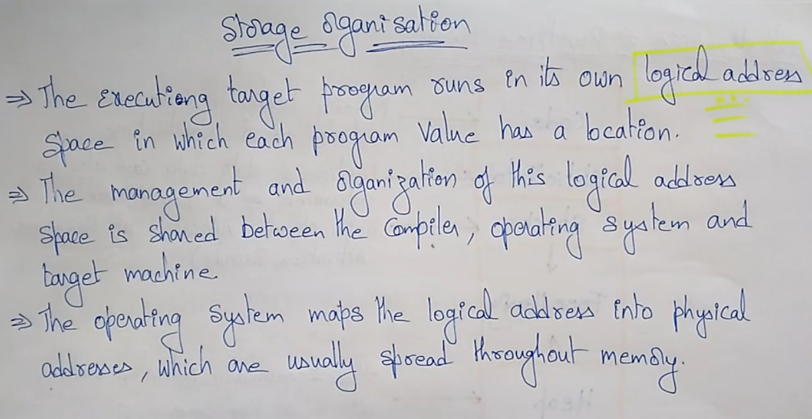

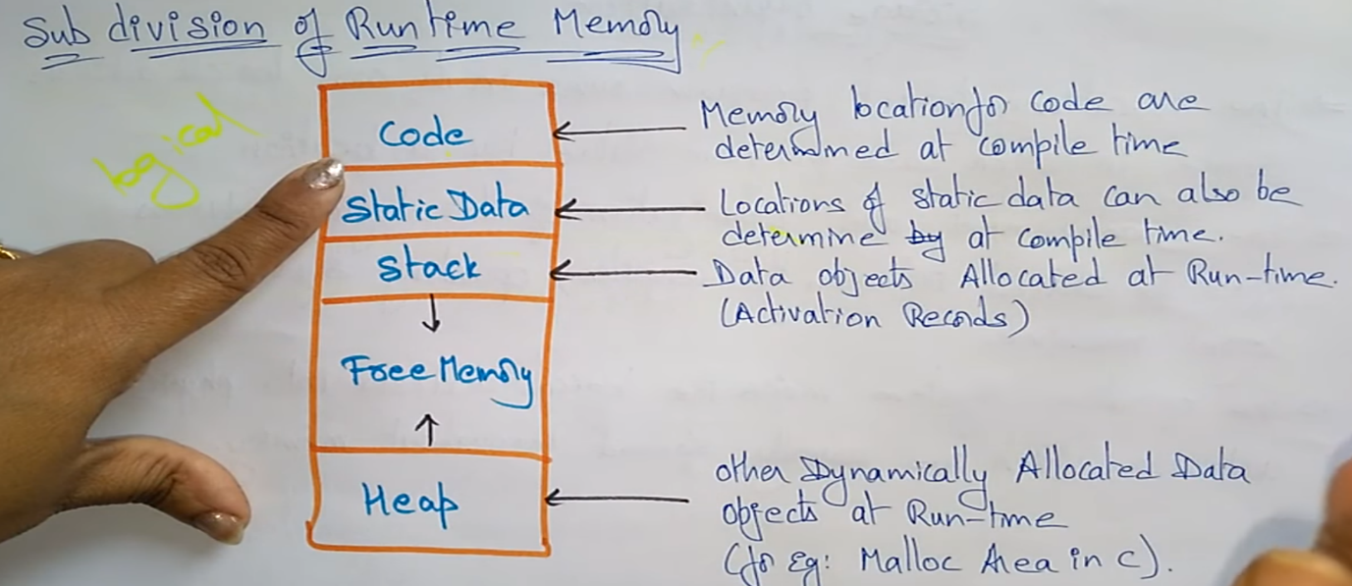

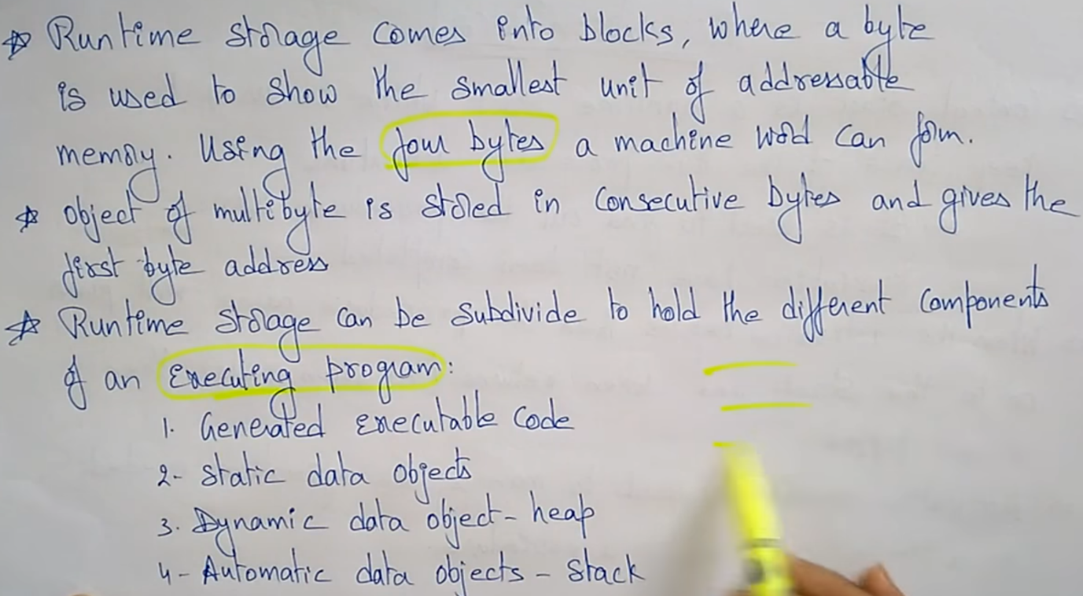

* **Storage Organization store the all information and data at run and compile time of program.**

**Stack Allocation Space**

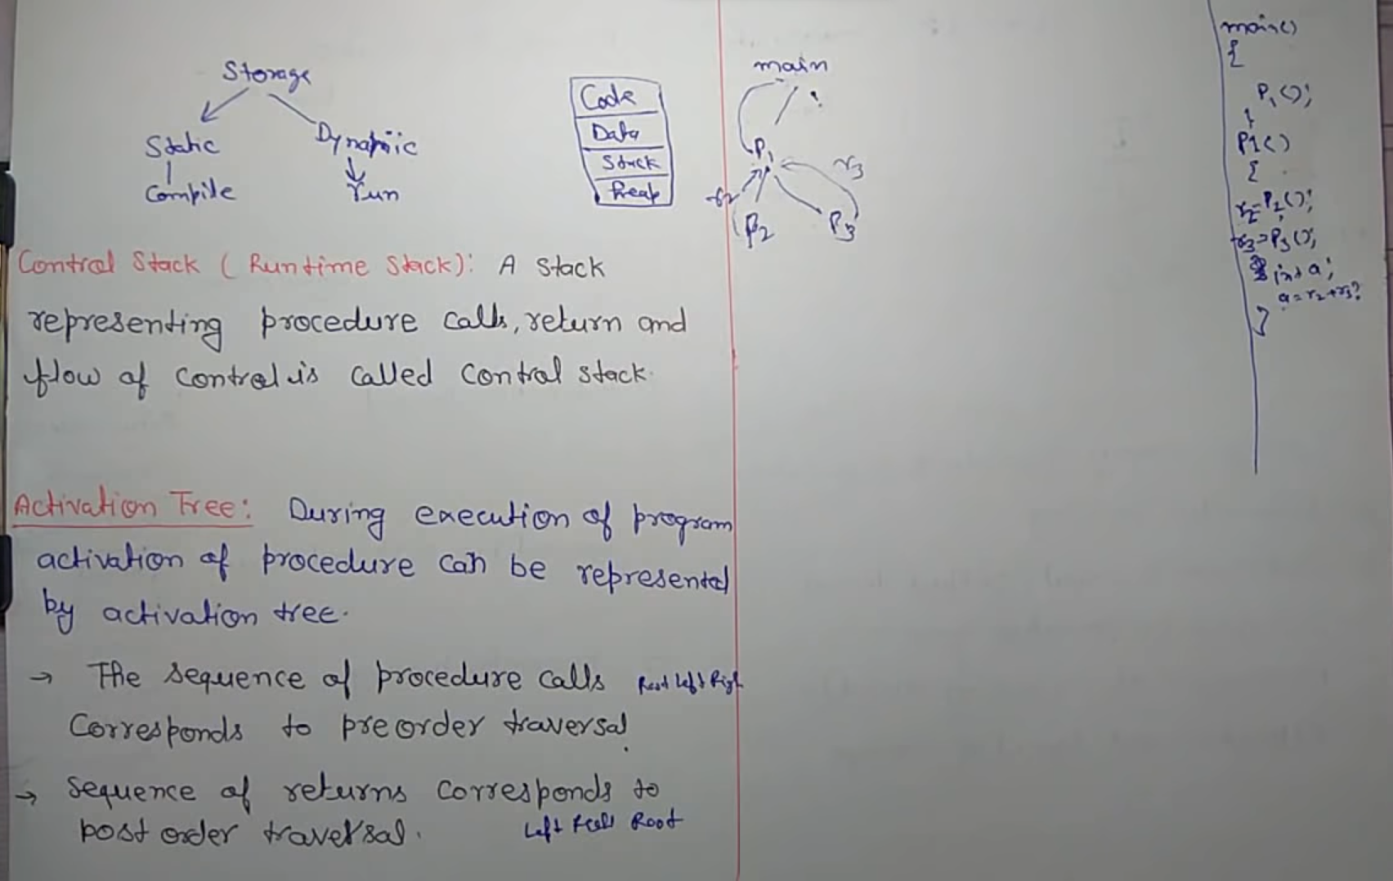

The stack allocation is a runtime storage management technique. That is use to store the data when program go to run from begin to end. The activation records are pushed and popped as activations begin and end respectively.

Storage for the locals in each call of the procedure is contained in the activation record for that call. Thus, locals are bound to fresh storage in each activation, because a new activation record is pushed onto the stack when the call is made.

# Access to Nonlocal Data on the Stack

The stack is a fundamental data structure used in computer programs to manage the flow of execution and store temporary data. Accessing data outside of the current scope or stack frame can lead to unexpected behavior, security vulnerabilities, and even crashes.

In general, accessing non-local data on the stack can be achieved through a variety of methods such as stack smashing, buffer overflow, or format string vulnerabilities. These techniques can potentially allow an attacker to manipulate the program's memory and execute arbitrary code.

It's essential to write secure code and follow best practices such as input validation, proper memory management, and using secure programming languages and frameworks to minimize the risk of stack-based attacks.

**Heap Management**

In computer programming, a heap is a region of dynamically allocated memory that is commonly used to store and manage data structures such as arrays, linked lists, trees, and other data structures that require dynamic memory allocation.

Unlike the stack, which is used for static memory allocation, the heap allows memory to be allocated and deallocated at runtime. The heap is managed by the operating system or runtime environment, and programs access the heap through memory allocation functions such as malloc() and free() in C and C++, or new and delete operators in languages such as C++ and Java.

One of the advantages of using a heap is that it allows data structures to be created and resized dynamically, which is especially useful when the size of the data structure is not known at compile time. However, heap management can be more complex than stack management, as it requires explicit allocation and deallocation of memory, and can be prone to memory leaks and other memory-related errors if not managed carefully.

Heap management refers to the management of dynamically allocated memory in a computer program. In programming languages such as C and C++, the heap is a region of memory that is allocated at runtime and can be accessed by the program through pointers.

Heap management involves allocating memory on the heap when it is needed, and releasing it when it is no longer needed. Failure to properly manage heap memory can lead to memory leaks, where memory is allocated but never released, or to the corruption of memory, where data is written to memory that has already been freed.

Common heap management techniques include manual memory management using functions such as malloc() and free(), and automatic memory management using garbage collection. In manual memory management, the programmer is responsible for explicitly allocating and deallocating memory. In automatic memory management, the system automatically deallocates memory that is no longer being used.

Heap management is an important aspect of programming, as it can greatly affect the performance, stability, and security of a program.

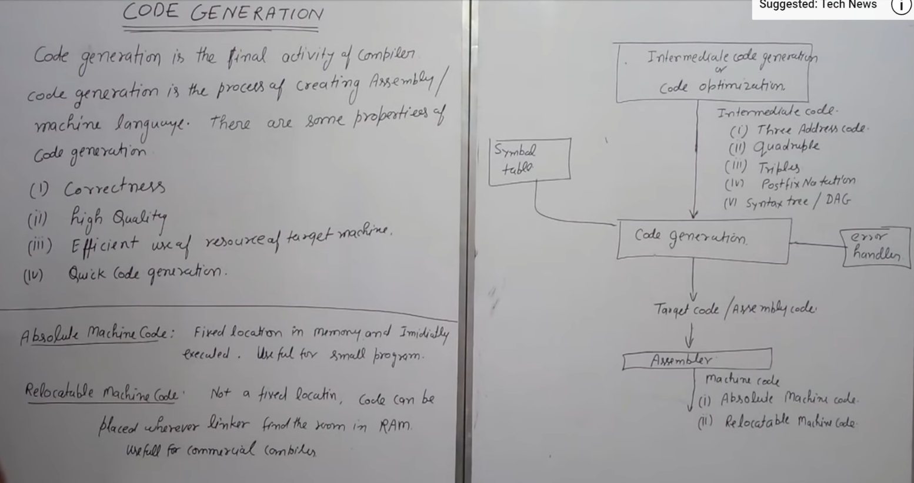**Issues in Code Generation**

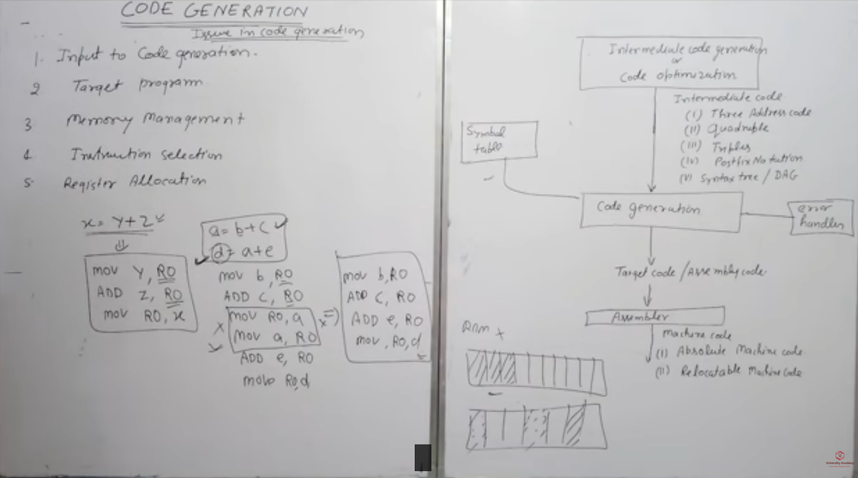

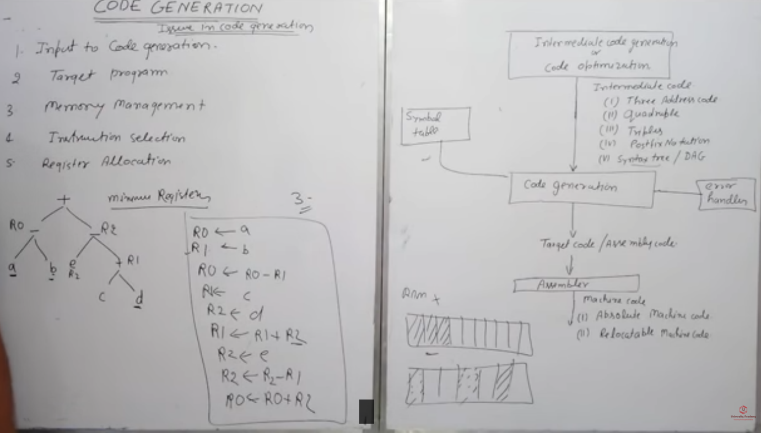

# Design Issues

In the code generation phase, various issues can arises:

1. Input to the code generator
2. Target program
3. Memory management
4. Instruction selection
5. Register allocation
6. Evaluation order

## **1. Input to the code generator**

* The input to the code generator contains the intermediate representation of the source program and the information of the symbol table. The source program is produced by the front end.
* Intermediate representation has the several choices:  
    a) Postfix notation  
    b) Syntax tree  
    c) Three address code

## **2. Target program:**

The target program is the output of the code generator. The output can be:

a) **Assembly language:** It allows subprogram to be separately compiled.

b) **Relocatable machine language:** It makes the process of code generation easier.

c) **Absolute machine language:** It can be placed in a fixed location in memory and can be executed immediately.

## **4. Instruction selection:**

* Nature of instruction set of the target machine should be complete and uniform.
* When you consider the efficiency of target machine then the instruction speed and machine idioms are important factors.
* The quality of the generated code can be determined by its speed and size.

### Example:

The Three address code is:

1. a:= b + c
2. d:= a + e

Inefficient assembly code is:

1. MOV b, R0              R0→b
2. ADD c, R0   R0      c + R0
3. MOV R0, a               a   →   R0
4. MOV a, R0      R0→  a
5. ADD e, R0               R0  →       e + R0
6. MOV R0, d               d    →  R0

## **5. Register allocation**

Register can be accessed faster than memory. The instructions involving operands in register are shorter and faster than those involving in memory operand.

The following sub problems arise when we use registers:

**Register allocation:** In register allocation, we select the set of variables that will reside in register.

**Register assignment:** In Register assignment, we pick the register that contains variable.

Certain machine requires even-odd pairs of registers for some operands and result.

### For example:

Consider the following division instruction of the form:

1. D x, y

Where,

**x** is the dividend even register in even/odd register pair

**y** is the divisor

**Even register** is used to hold the reminder.

**Old register** is used to hold the quotient.

## **6. Evaluation order**

The efficiency of the target code can be affected by the order in which the computations are performed. Some computation orders need fewer registers to hold results of intermediate than others.

# Simple Code Generator

Code generator is used to produce the target code for three-address statements. It uses registers to store the operands of the three address statement.

### Example:

Consider the three address statement x:= y + z. It can have the following sequence of codes:

MOV x, R0

ADD y, R0

## **Register and Address Descriptors:**

* A register descriptor contains the track of what is currently in each register. The register descriptors show that all the registers are initially empty.
* An address descriptor is used to store the location where current value of the name can be found at run time.

## **A code-generation algorithm:**

The algorithm takes a sequence of three-address statements as input. For each three address statement of the form a:= b op c perform the various actions. These are as follows:

1. Invoke a function getreg to find out the location L where the result of computation b op c should be stored.
2. Consult the address description for y to determine y'. If the value of y currently in memory and register both then prefer the register y' . If the value of y is not already in L then generate the instruction **MOV y' , L** to place a copy of y in L.
3. Generate the instruction **OP z' , L** where z' is used to show the current location of z. if z is in both then prefer a register to a memory location. Update the address descriptor of x to indicate that x is in location L. If x is in L then update its descriptor and remove x from all other descriptor.
4. If the current value of y or z have no next uses or not live on exit from the block or in register then alter the register descriptor to indicate that after execution of x : = y op z those register will no longer contain y or z.

### Generating Code for Assignment Statements:

The assignment statement d:= (a-b) + (a-c) + (a-c) can be translated into the following sequence of three address code:

1. t:= a-b
2. u:= a-c
3. v:= t +u
4. d:= v+u

Code sequence for the example is as follows:

|  |  |  |  |
| --- | --- | --- | --- |
| **Statement** | **Code Generated** | **Register descriptor Register empty** | **Address descriptor** |
| t:= a - b | MOV a, R0 SUB b, R0 | R0 contains t | t in R0 |
| u:= a - c | MOV a, R1 SUB c, R1 | R0 contains t R1 contains u | t in R0 u in R1 |
| v:= t + u | ADD R1, R0 | R0 contains v R1 contains u | u in R1 v in R1 |
| d:= v + u | ADD R1, R0 MOV R0, d | R0 contains d | d in R0 d in R0 and memory |